- 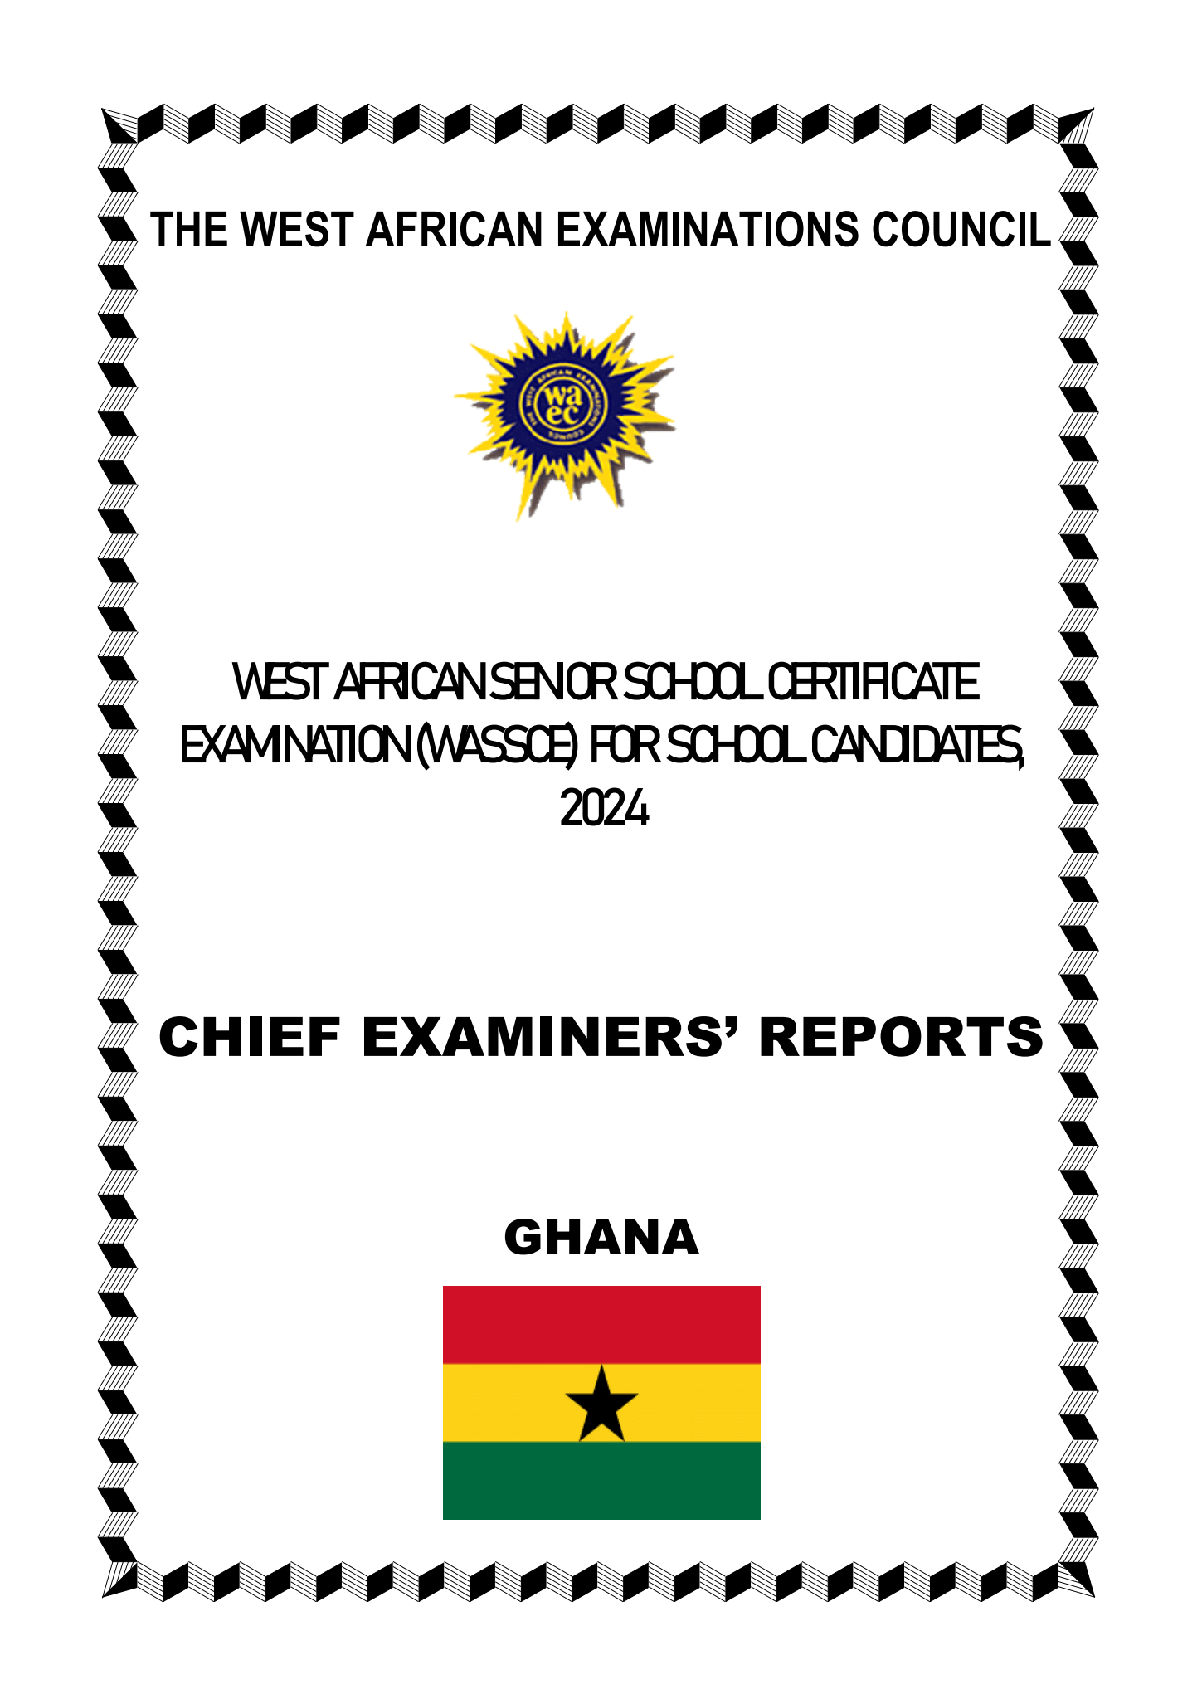
iiTHEWEST AFRICAN EXAMINATIONS COUNCILWEST AFRICAN SENIOR SCHOOL CERTIFICATEEXAMINATION (WASSCE) FOR SCHOOL CANDIDATES,2024CHIEF EXAMINERS’ REPORTSGHANA
- 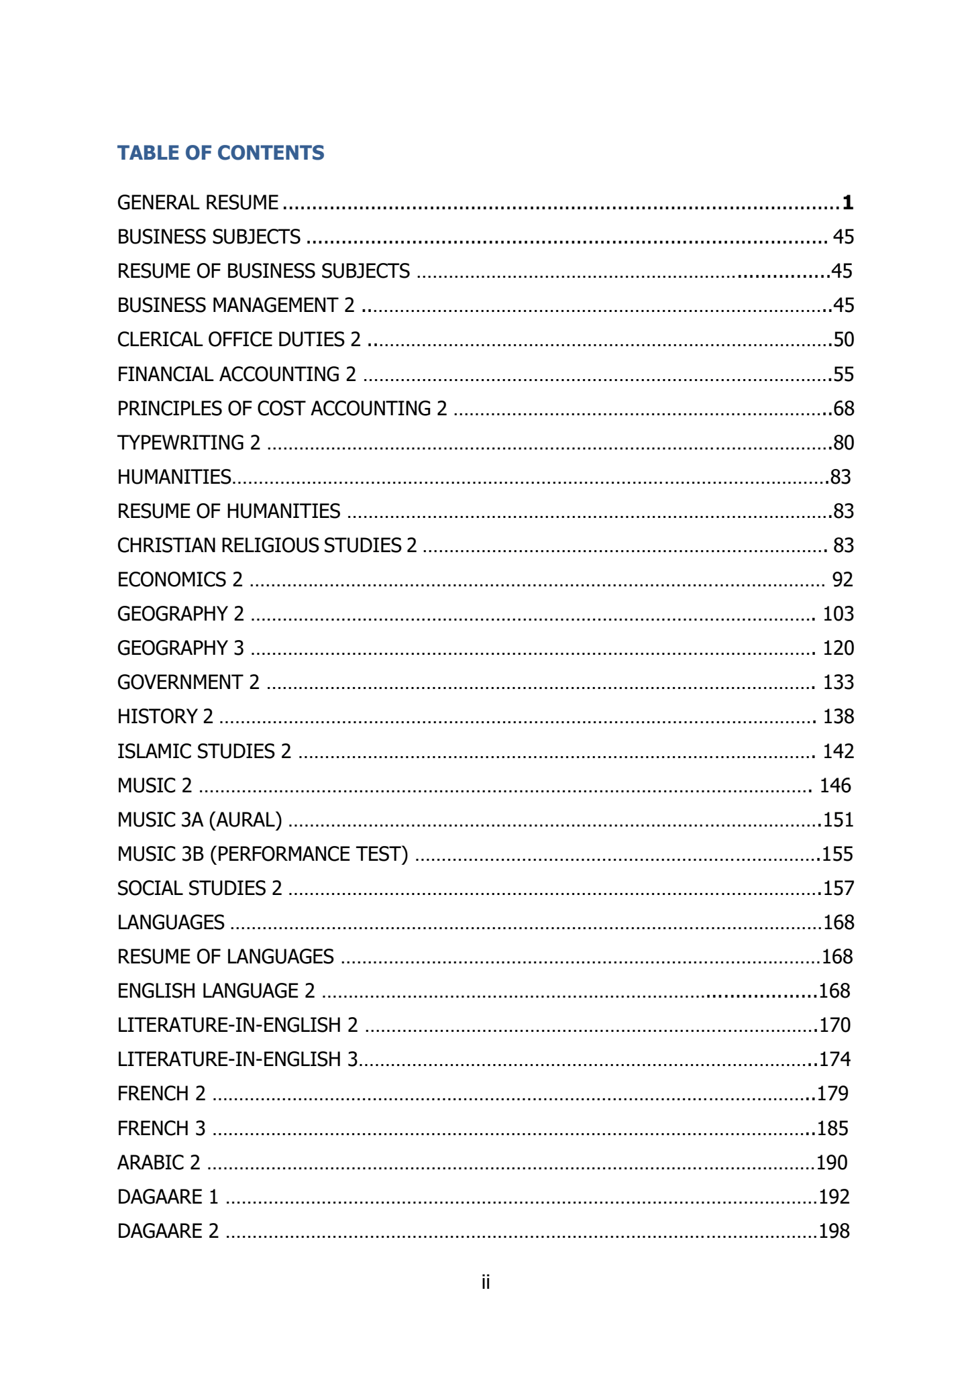
iiTABLE OF CONTENTSGENERAL RESUME...............................................................................................1BUSINESS SUBJECTS.........................................................................................45RESUME OF BUSINESS SUBJECTS ............................................................................45BUSINESSMANAGEMENT2 ........................................................................................45CLERICALOFFICE DUTIES2 .......................................................................................50FINANCIAL ACCOUNTING2........................................................................................55PRINCIPLES OF COST ACCOUNTING2.......................................................................68TYPEWRITING2..........................................................................................................80HUMANITIES................................................................................................................83RESUME OF HUMANITIES...........................................................................................83CHRISTIAN RELIGIOUS STUDIES 2............................................................................83ECONOMICS 2............................................................................................................92GEOGRAPHY 2..........................................................................................................103GEOGRAPHY 3.......................................................................................................... 120GOVERNMENT 2.......................................................................................................133HISTORY 2................................................................................................................138ISLAMIC STUDIES 2.................................................................................................142MUSIC 2...................................................................................................................146MUSIC 3A (AURAL)....................................................................................................151MUSIC 3B (PERFORMANCE TEST) ............................................................................155SOCIAL STUDIES 2 ....................................................................................................157LANGUAGES...............................................................................................................168RESUME OF LANGUAGES..........................................................................................168ENGLISH LANGUAGE 2...........................................................................................168LITERATURE-IN-ENGLISH 2.....................................................................................170LITERATURE-IN-ENGLISH 3......................................................................................174FRENCH 2.................................................................................................................179FRENCH 3.................................................................................................................185ARABIC 2..................................................................................................................190DAGAARE 1...............................................................................................................192DAGAARE 2...............................................................................................................198
- 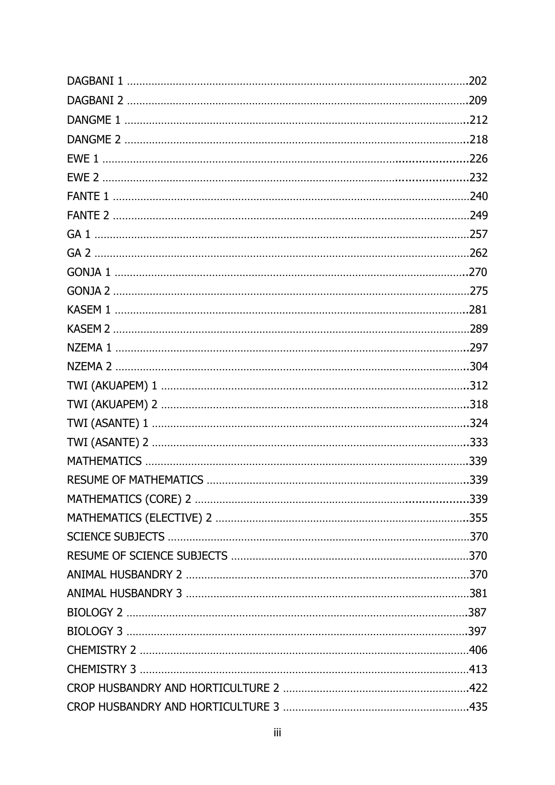
iiiDAGBANI 1................................................................................................................202DAGBANI 2................................................................................................................209DANGME 1.................................................................................................................212DANGME 2.................................................................................................................218EWE 1......................................................................................................................226EWE 2......................................................................................................................232FANTE 1.....................................................................................................................240FANTE 2.....................................................................................................................249GA 1...........................................................................................................................257GA 2...........................................................................................................................262GONJA 1....................................................................................................................270GONJA 2.....................................................................................................................275KASEM 1....................................................................................................................281KASEM 2.....................................................................................................................289NZEMA 1....................................................................................................................297NZEMA 2....................................................................................................................304TWI (AKUAPEM)1.....................................................................................................312TWI (AKUAPEM) 2.....................................................................................................318TWI (ASANTE) 1........................................................................................................324TWI (ASANTE) 2........................................................................................................333MATHEMATICS..........................................................................................................339RESUME OF MATHEMATICS......................................................................................339MATHEMATICS (CORE) 2........................................................................................339MATHEMATICS (ELECTIVE) 2...................................................................................355SCIENCE SUBJECTS...................................................................................................370RESUME OF SCIENCE SUBJECTS..............................................................................370ANIMAL HUSBANDRY 2.............................................................................................370ANIMAL HUSBANDRY 3.............................................................................................381BIOLOGY 2................................................................................................................387BIOLOGY 3................................................................................................................397CHEMISTRY 2............................................................................................................406CHEMISTRY 3............................................................................................................413CROP HUSBANDRY AND HORTICULTURE 2.............................................................422CROP HUSBANDRY AND HORTICULTURE 3.............................................................435
- 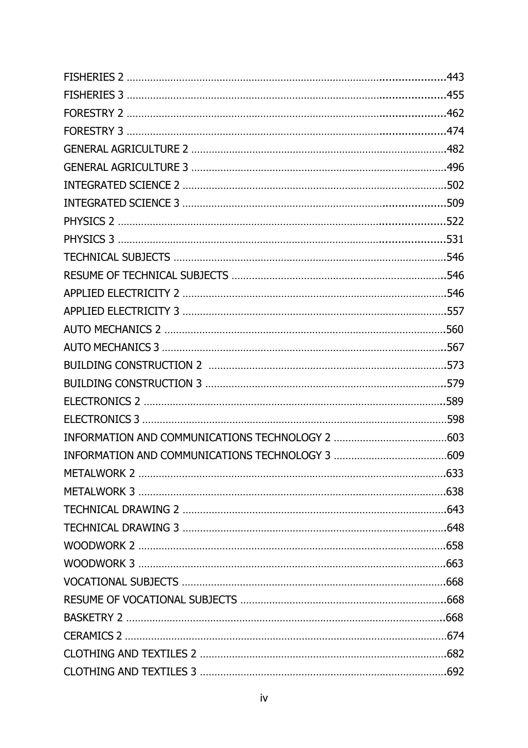
ivFISHERIES 2............................................................................................................443FISHERIES 3............................................................................................................455FORESTRY 2............................................................................................................462FORESTRY 3............................................................................................................474GENERAL AGRICULTURE 2........................................................................................482GENERAL AGRICULTURE 3........................................................................................496INTEGRATED SCIENCE 2...........................................................................................502INTEGRATED SCIENCE 3.........................................................................................509PHYSICS 2...............................................................................................................522PHYSICS 3...............................................................................................................531TECHNICAL SUBJECTS..............................................................................................546RESUME OF TECHNICAL SUBJECTS..........................................................................546APPLIED ELECTRICITY 2...........................................................................................546APPLIED ELECTRICITY 3...........................................................................................557AUTO MECHANICS 2.................................................................................................560AUTO MECHANICS 3..................................................................................................567BUILDING CONSTRUCTION2..................................................................................573BUILDING CONSTRUCTION 3...................................................................................579ELECTRONICS 2........................................................................................................589ELECTRONICS 3.........................................................................................................598INFORMATION AND COMMUNICATIONS TECHNOLOGY 2.......................................603INFORMATION AND COMMUNICATIONS TECHNOLOGY 3.......................................609METALWORK 2..........................................................................................................633METALWORK 3..........................................................................................................638TECHNICAL DRAWING 2...........................................................................................643TECHNICAL DRAWING 3...........................................................................................648WOODWORK 2..........................................................................................................658WOODWORK 3..........................................................................................................663VOCATIONAL SUBJECTS...........................................................................................668RESUME OF VOCATIONAL SUBJECTS.......................................................................668BASKETRY 2..............................................................................................................668CERAMICS 2...............................................................................................................674CLOTHING AND TEXTILES 2.....................................................................................682CLOTHING AND TEXTILES 3.....................................................................................692
- 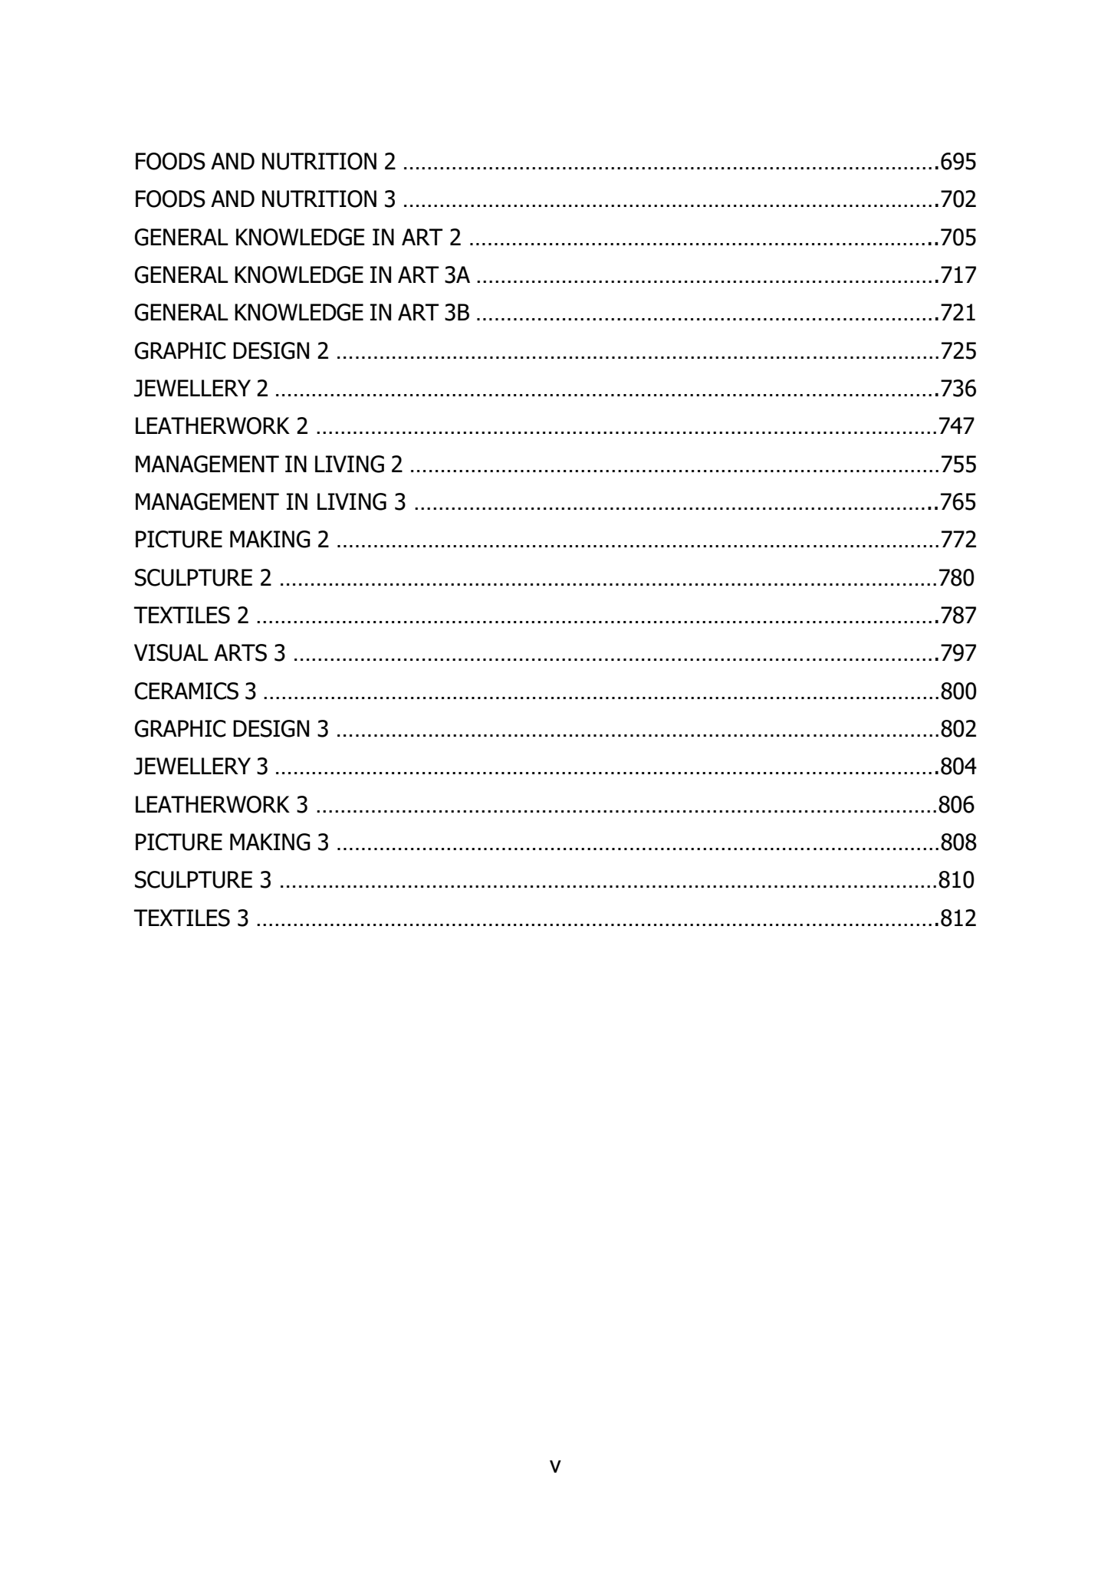
vFOODS AND NUTRITION 2........................................................................................695FOODS AND NUTRITION 3........................................................................................702GENERAL KNOWLEDGE IN ART 2.............................................................................705GENERAL KNOWLEDGE IN ART 3A............................................................................717GENERAL KNOWLEDGE IN ART 3B............................................................................721GRAPHIC DESIGN 2...................................................................................................725JEWELLERY 2.............................................................................................................736LEATHERWORK 2......................................................................................................747MANAGEMENT IN LIVING 2.......................................................................................755MANAGEMENT IN LIVING 3......................................................................................765PICTURE MAKING 2...................................................................................................772SCULPTURE 2............................................................................................................780TEXTILES 2................................................................................................................787VISUAL ARTS 3..........................................................................................................797CERAMICS 3...............................................................................................................800GRAPHIC DESIGN 3...................................................................................................802JEWELLERY 3.............................................................................................................804LEATHERWORK 3......................................................................................................806PICTURE MAKING 3...................................................................................................808SCULPTURE 3............................................................................................................810TEXTILES 3................................................................................................................812
- 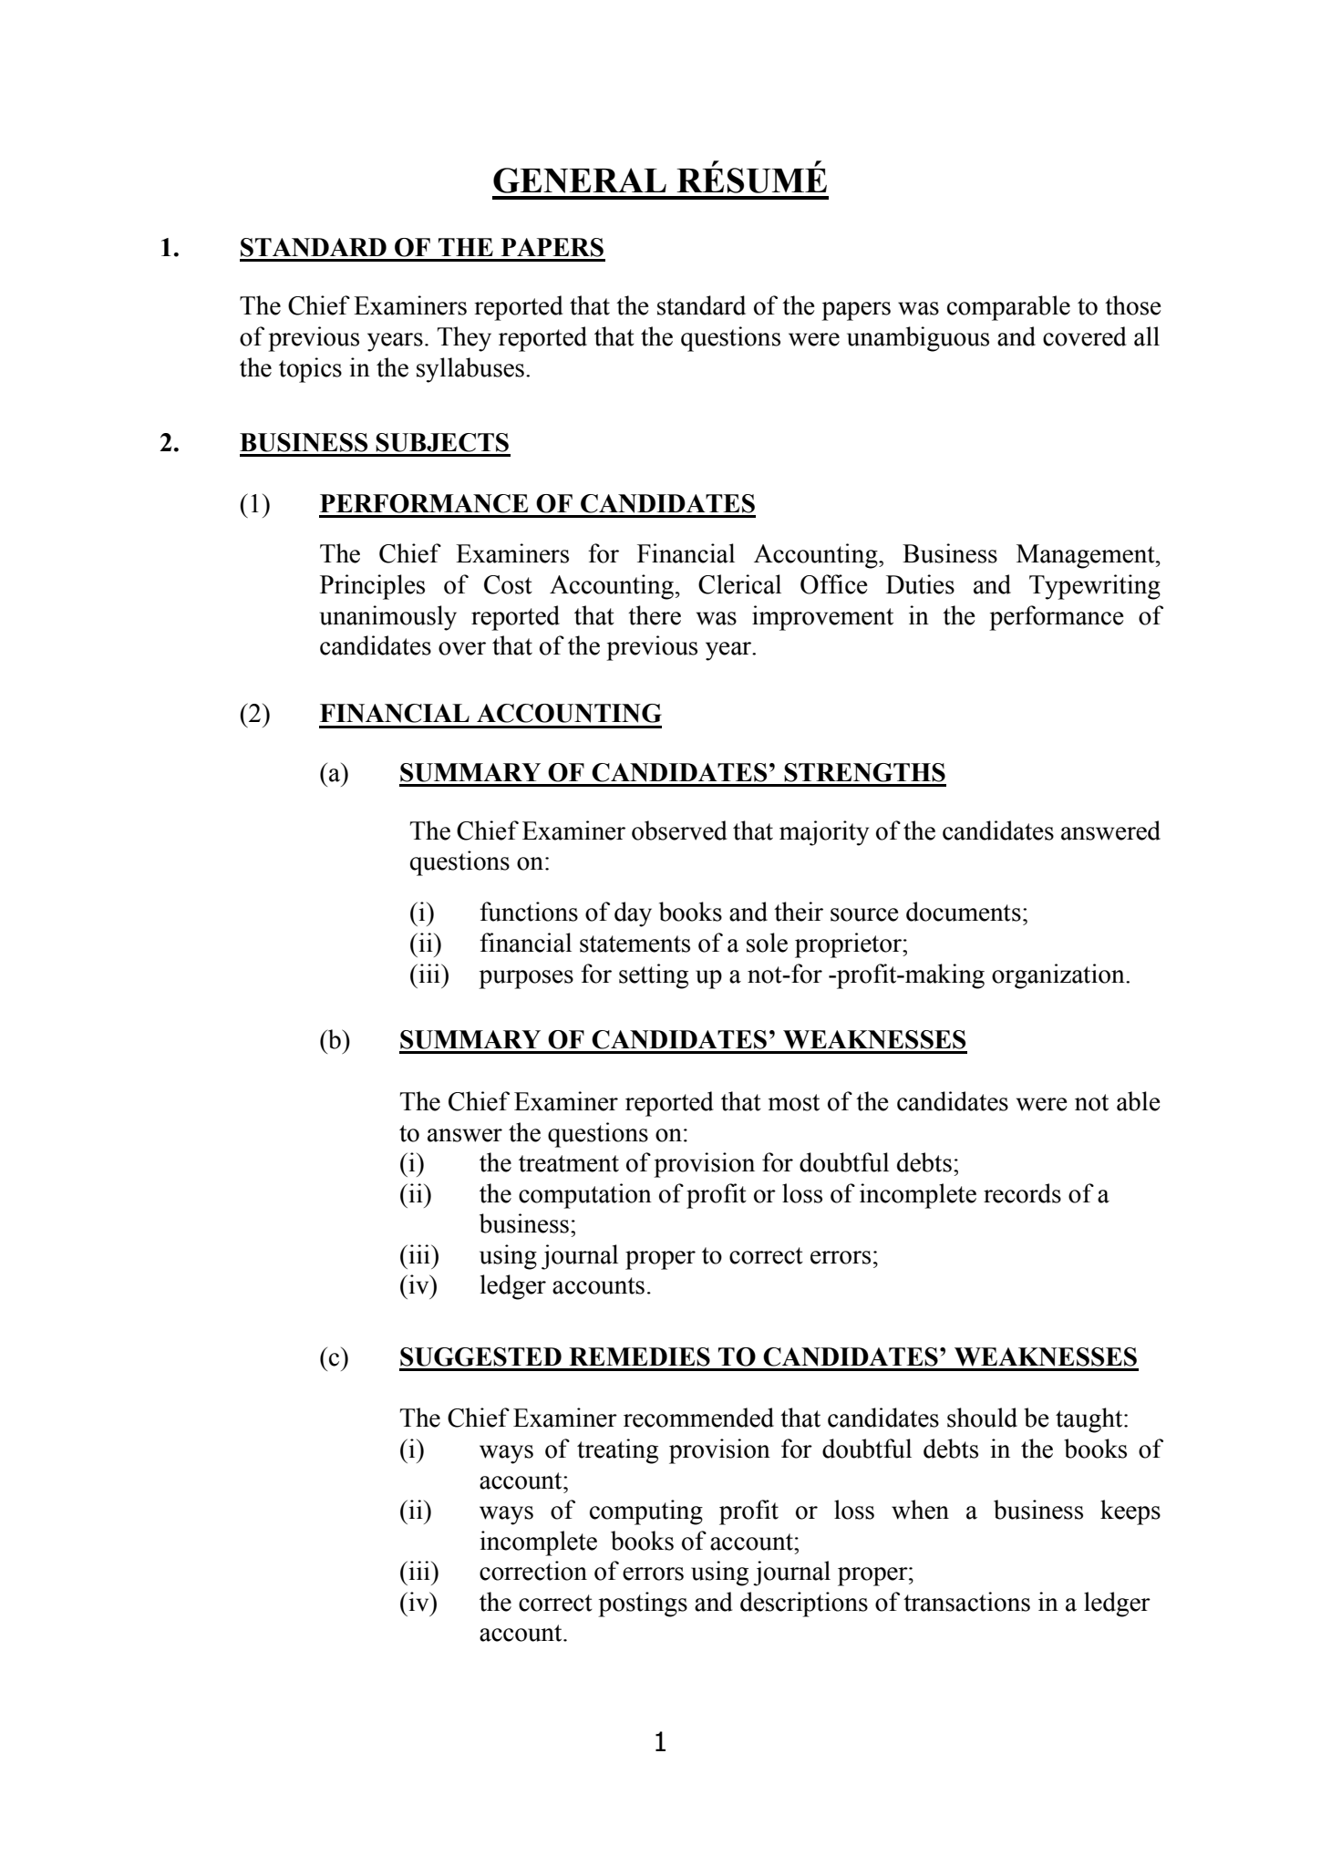
1GENERAL RÉSUMÉ1.STANDARD OF THE PAPERSThe Chief Examiners reported that the standard ofthe papers was comparable to thoseof previous years. They reported that the questions were unambiguous and covered allthe topics in the syllabuses.2.BUSINESS SUBJECTS(1)PERFORMANCE OF CANDIDATESThe Chief Examiners for Financial Accounting, Business Management,Principles of Cost Accounting, Clerical Office Duties and Typewritingunanimously reported that there was improvement in the performance ofcandidates over that of the previous year.(2)FINANCIAL ACCOUNTING(a)SUMMARY OFCANDIDATES’ STRENGTHSThe Chief Examiner observed that majority of the candidates answeredquestions on:(i)functions of day books and their source documents;(ii)financial statements of a sole proprietor;(iii)purposes for setting up a not-for-profit-making organization.(b)SUMMARY OF CANDIDATES’ WEAKNESSESThe Chief Examiner reported that most of the candidates were not ableto answer the questions on:(i)the treatment of provision for doubtful debts;(ii)the computation of profit or loss of incomplete records of abusiness;(iii)using journal proper to correct errors;(iv)ledger accounts.(c)SUGGESTED REMEDIES TO CANDIDATES’ WEAKNESSESThe Chief Examiner recommended that candidates should be taught:(i)ways of treating provision for doubtful debts in the books ofaccount;(ii)ways of computing profit or loss when a business keepsincompletebooks of account;(iii)correction of errors using journal proper;(iv)the correct postings and descriptions of transactions in a ledgeraccount.
- 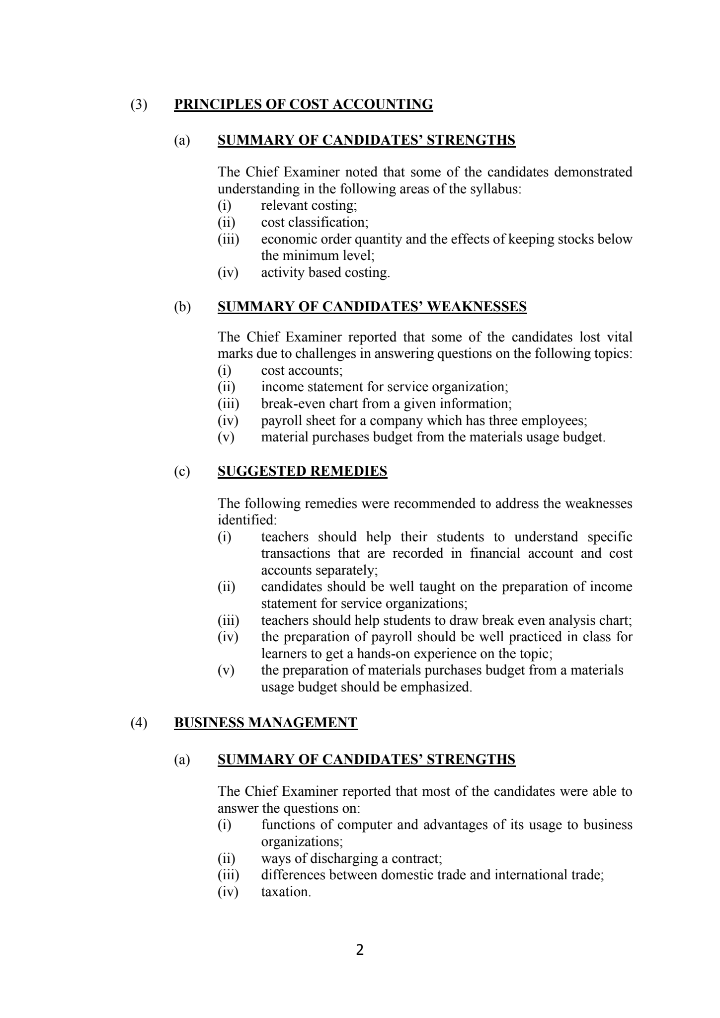
2(3)PRINCIPLES OF COST ACCOUNTING(a)SUMMARY OF CANDIDATES’ STRENGTHSThe Chief Examiner noted that some of the candidates demonstratedunderstanding in the following areas ofthe syllabus:(i)relevant costing;(ii)cost classification;(iii)economic order quantity and the effects of keeping stocks belowtheminimum level;(iv)activity based costing.(b)SUMMARY OF CANDIDATES’ WEAKNESSESThe Chief Examiner reported that some of thecandidates lost vitalmarks due to challenges in answering questions on the following topics:(i)cost accounts;(ii)income statement for service organization;(iii)break-even chart from a given information;(iv)payroll sheet for a company which has three employees;(v)material purchases budget from the materials usage budget.(c)SUGGESTED REMEDIESThe following remedies were recommended to address the weaknessesidentified:(i)teachers should help their students to understand specifictransactions thatare recorded in financial account and costaccounts separately;(ii)candidates should be well taught on the preparation of incomestatement for service organizations;(iii)teachers should help students to draw break even analysis chart;(iv)the preparation of payroll should be well practiced in class forlearners toget a hands-on experience on the topic;(v)the preparation of materials purchases budget from a materialsusagebudget should beemphasized.(4)BUSINESS MANAGEMENT(a)SUMMARY OF CANDIDATES’ STRENGTHSThe Chief Examiner reported that most of the candidates were able toanswer the questions on:(i)functions of computer andadvantages ofits usage to businessorganizations;(ii)ways of discharging a contract;(iii)differences between domestic trade and international trade;(iv)taxation.
- 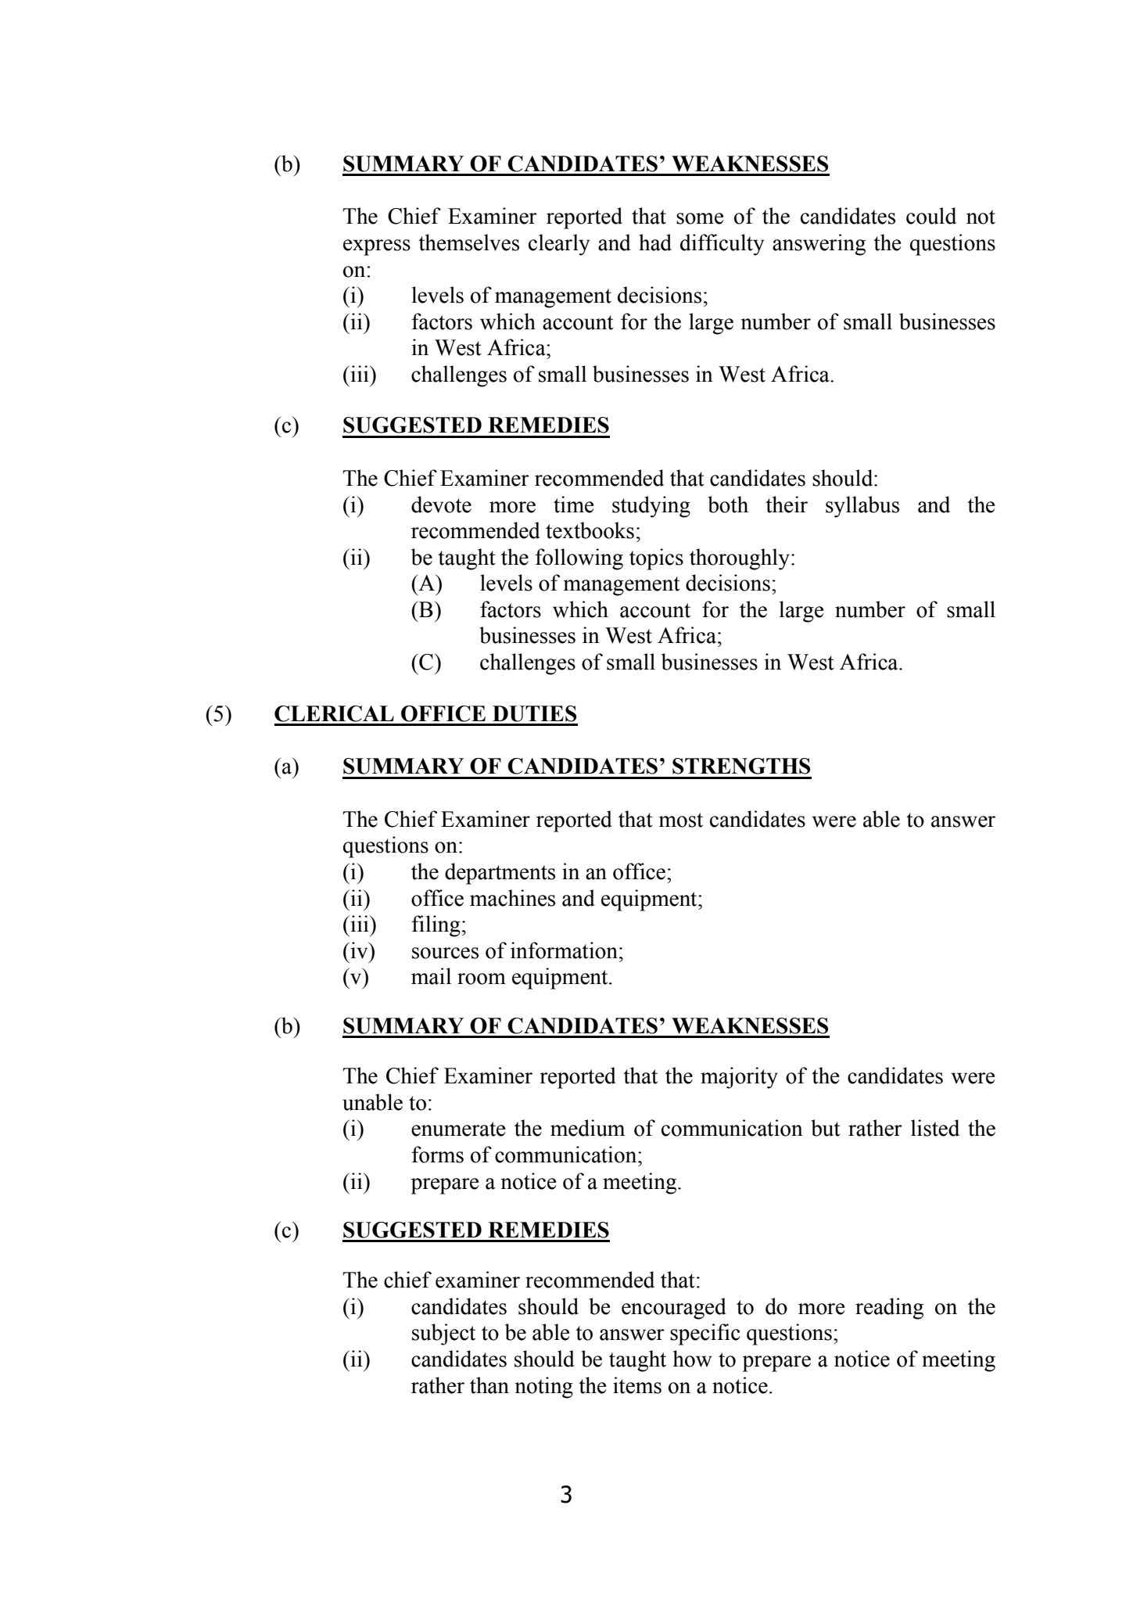
3(b)SUMMARY OF CANDIDATES’ WEAKNESSESThe Chief Examiner reported that some of the candidates could notexpress themselves clearly andhad difficulty answering the questionson:(i)levels of management decisions;(ii)factors which account for the large number of small businessesin West Africa;(iii)challenges of small businesses in West Africa.(c)SUGGESTED REMEDIESThe Chief Examinerrecommended that candidates should:(i)devote more time studying both their syllabus and therecommended textbooks;(ii)be taught the following topics thoroughly:(A)levels of management decisions;(B)factors which account for the large number of smallbusinesses in West Africa;(C)challenges of small businesses in West Africa.(5)CLERICAL OFFICE DUTIES(a)SUMMARY OF CANDIDATES’ STRENGTHSThe Chief Examiner reported that most candidates were able to answerquestions on:(i)the departments in an office;(ii)officemachines and equipment;(iii)filing;(iv)sources of information;(v)mail room equipment.(b)SUMMARY OF CANDIDATES’ WEAKNESSESThe Chief Examiner reported that the majority of the candidates wereunable to:(i)enumerate the medium of communication but ratherlisted theforms of communication;(ii)prepare a notice of a meeting.(c)SUGGESTED REMEDIESThe chief examiner recommended that:(i)candidates should be encouraged to do more reading on thesubject to beable to answer specific questions;(ii)candidates should be taught how to prepare a notice of meetingratherthannoting the items on a notice.
- 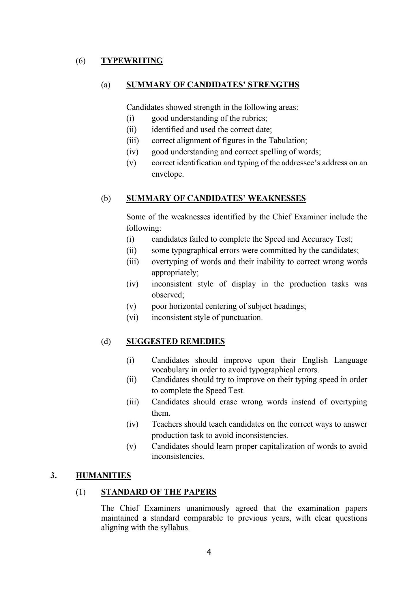
4(6)TYPEWRITING(a)SUMMARY OFCANDIDATES’ STRENGTHSCandidates showed strength in the following areas:(i)good understanding of the rubrics;(ii)identified and used the correct date;(iii)correct alignment of figures in the Tabulation;(iv)good understanding and correctspelling of words;(v)correct identification and typing of the addressee’s address on anenvelope.(b)SUMMARY OF CANDIDATES’ WEAKNESSESSome of the weaknesses identified by the Chief Examiner include thefollowing:(i)candidates failed tocomplete the Speed and Accuracy Test;(ii)some typographical errors were committed by the candidates;(iii)overtyping of words and their inability to correct wrong wordsappropriately;(iv)inconsistent style of display in the production tasks wasobserved;(v)poor horizontal centering of subject headings;(vi)inconsistent style of punctuation.(d)SUGGESTED REMEDIES(i)Candidates should improve upon their English Languagevocabulary in order to avoid typographical errors.(ii)Candidates should try to improve on their typing speed in orderto complete the Speed Test.(iii)Candidates should erase wrong words instead of overtypingthem.(iv)Teachers should teach candidates on the correct ways to answerproduction task to avoid inconsistencies.(v)Candidates should learn proper capitalization of words to avoidinconsistencies.3.HUMANITIES(1)STANDARD OF THE PAPERSThe Chief Examiners unanimously agreed that the examination papersmaintained a standard comparable to previous years,with clear questionsaligning with the syllabus.
- 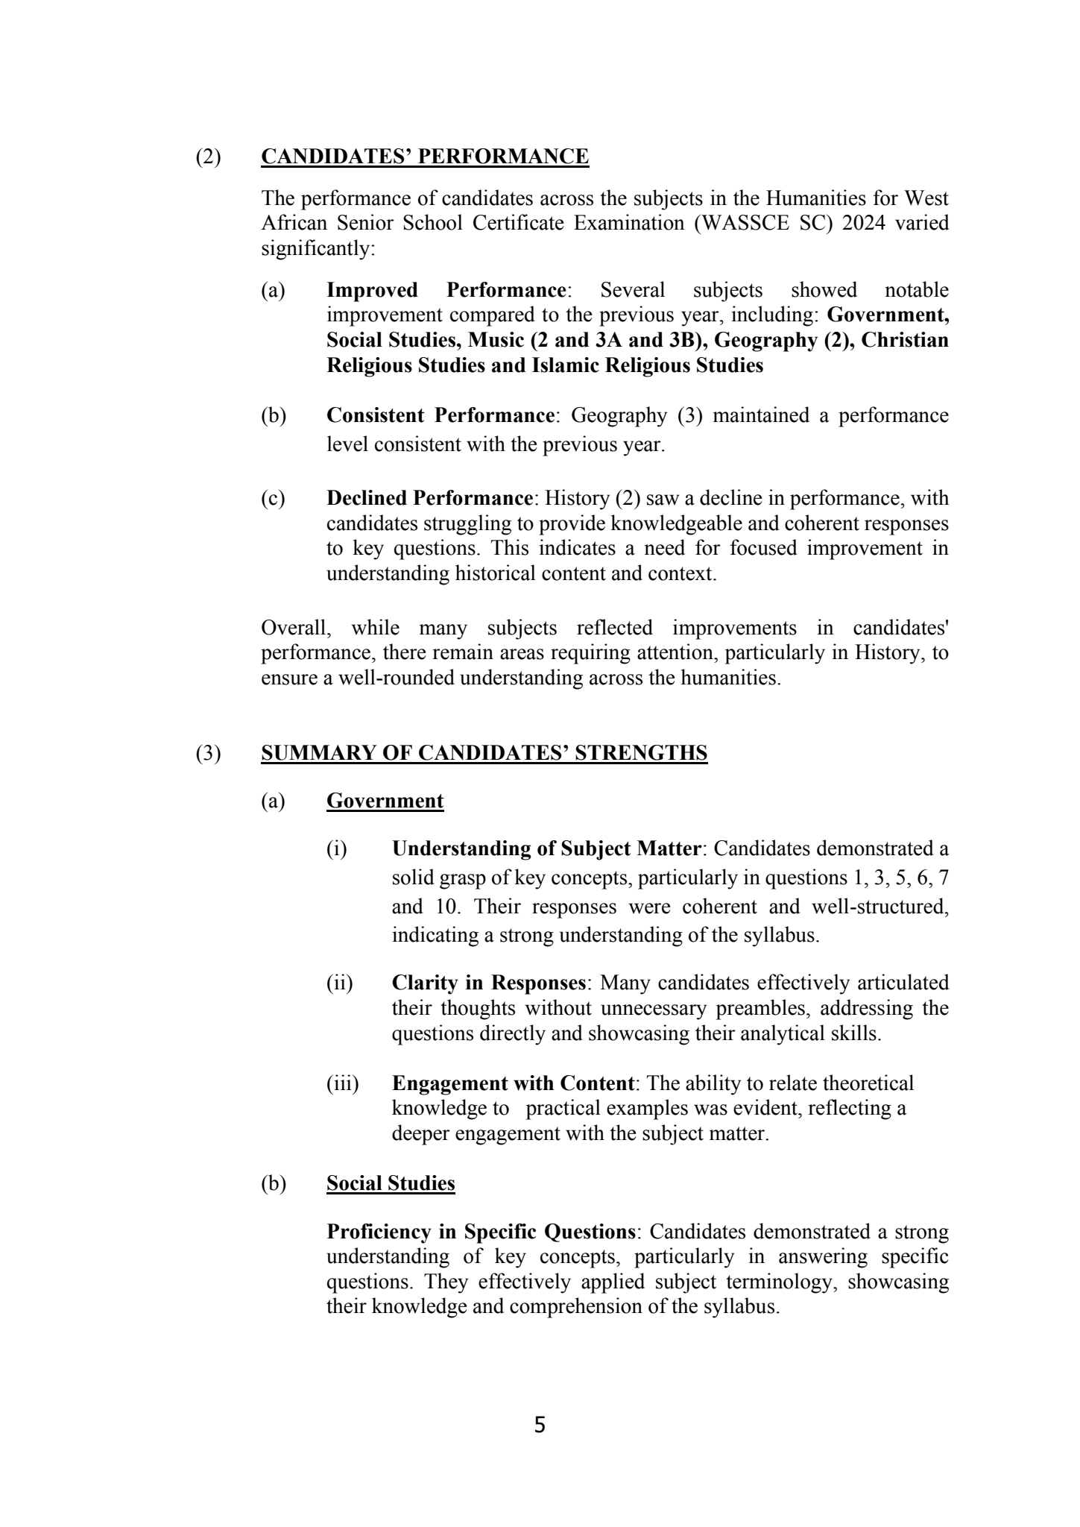
5(2)CANDIDATES’ PERFORMANCEThe performance of candidates across the subjects in the Humanities for WestAfrican Senior School Certificate Examination (WASSCESC) 2024 variedsignificantly:(a)Improved Performance: Several subjects showed notableimprovement compared to the previous year, including:Government,Social Studies, Music (2 and 3A and 3B),Geography (2),ChristianReligious Studies and Islamic Religious Studies(b)Consistent Performance: Geography (3) maintained a performancelevel consistent with the previous year.(c)Declined Performance: History (2) saw a decline in performance, withcandidates struggling to provide knowledgeable and coherent responsesto key questions. This indicates a need for focused improvement inunderstanding historical content and context.Overall, while many subjects reflected improvements in candidates'performance, there remain areas requiring attention, particularly in History, toensure a well-rounded understanding across the humanities.(3)SUMMARY OF CANDIDATES’ STRENGTHS(a)Government(i)Understanding of Subject Matter: Candidates demonstrated asolid grasp of keyconcepts, particularly in questions 1, 3, 5, 6, 7and 10. Their responses were coherent and well-structured,indicating a strong understanding of the syllabus.(ii)Clarity in Responses: Many candidates effectively articulatedtheir thoughtswithout unnecessary preambles, addressing thequestions directly and showcasing their analytical skills.(iii)Engagement with Content: The ability to relate theoreticalknowledge to practical examples was evident, reflecting adeeper engagement with the subject matter.(b)Social StudiesProficiency in Specific Questions: Candidates demonstrated a strongunderstanding of key concepts, particularly in answering specificquestions. They effectively applied subject terminology, showcasingtheirknowledge and comprehension of the syllabus.
- 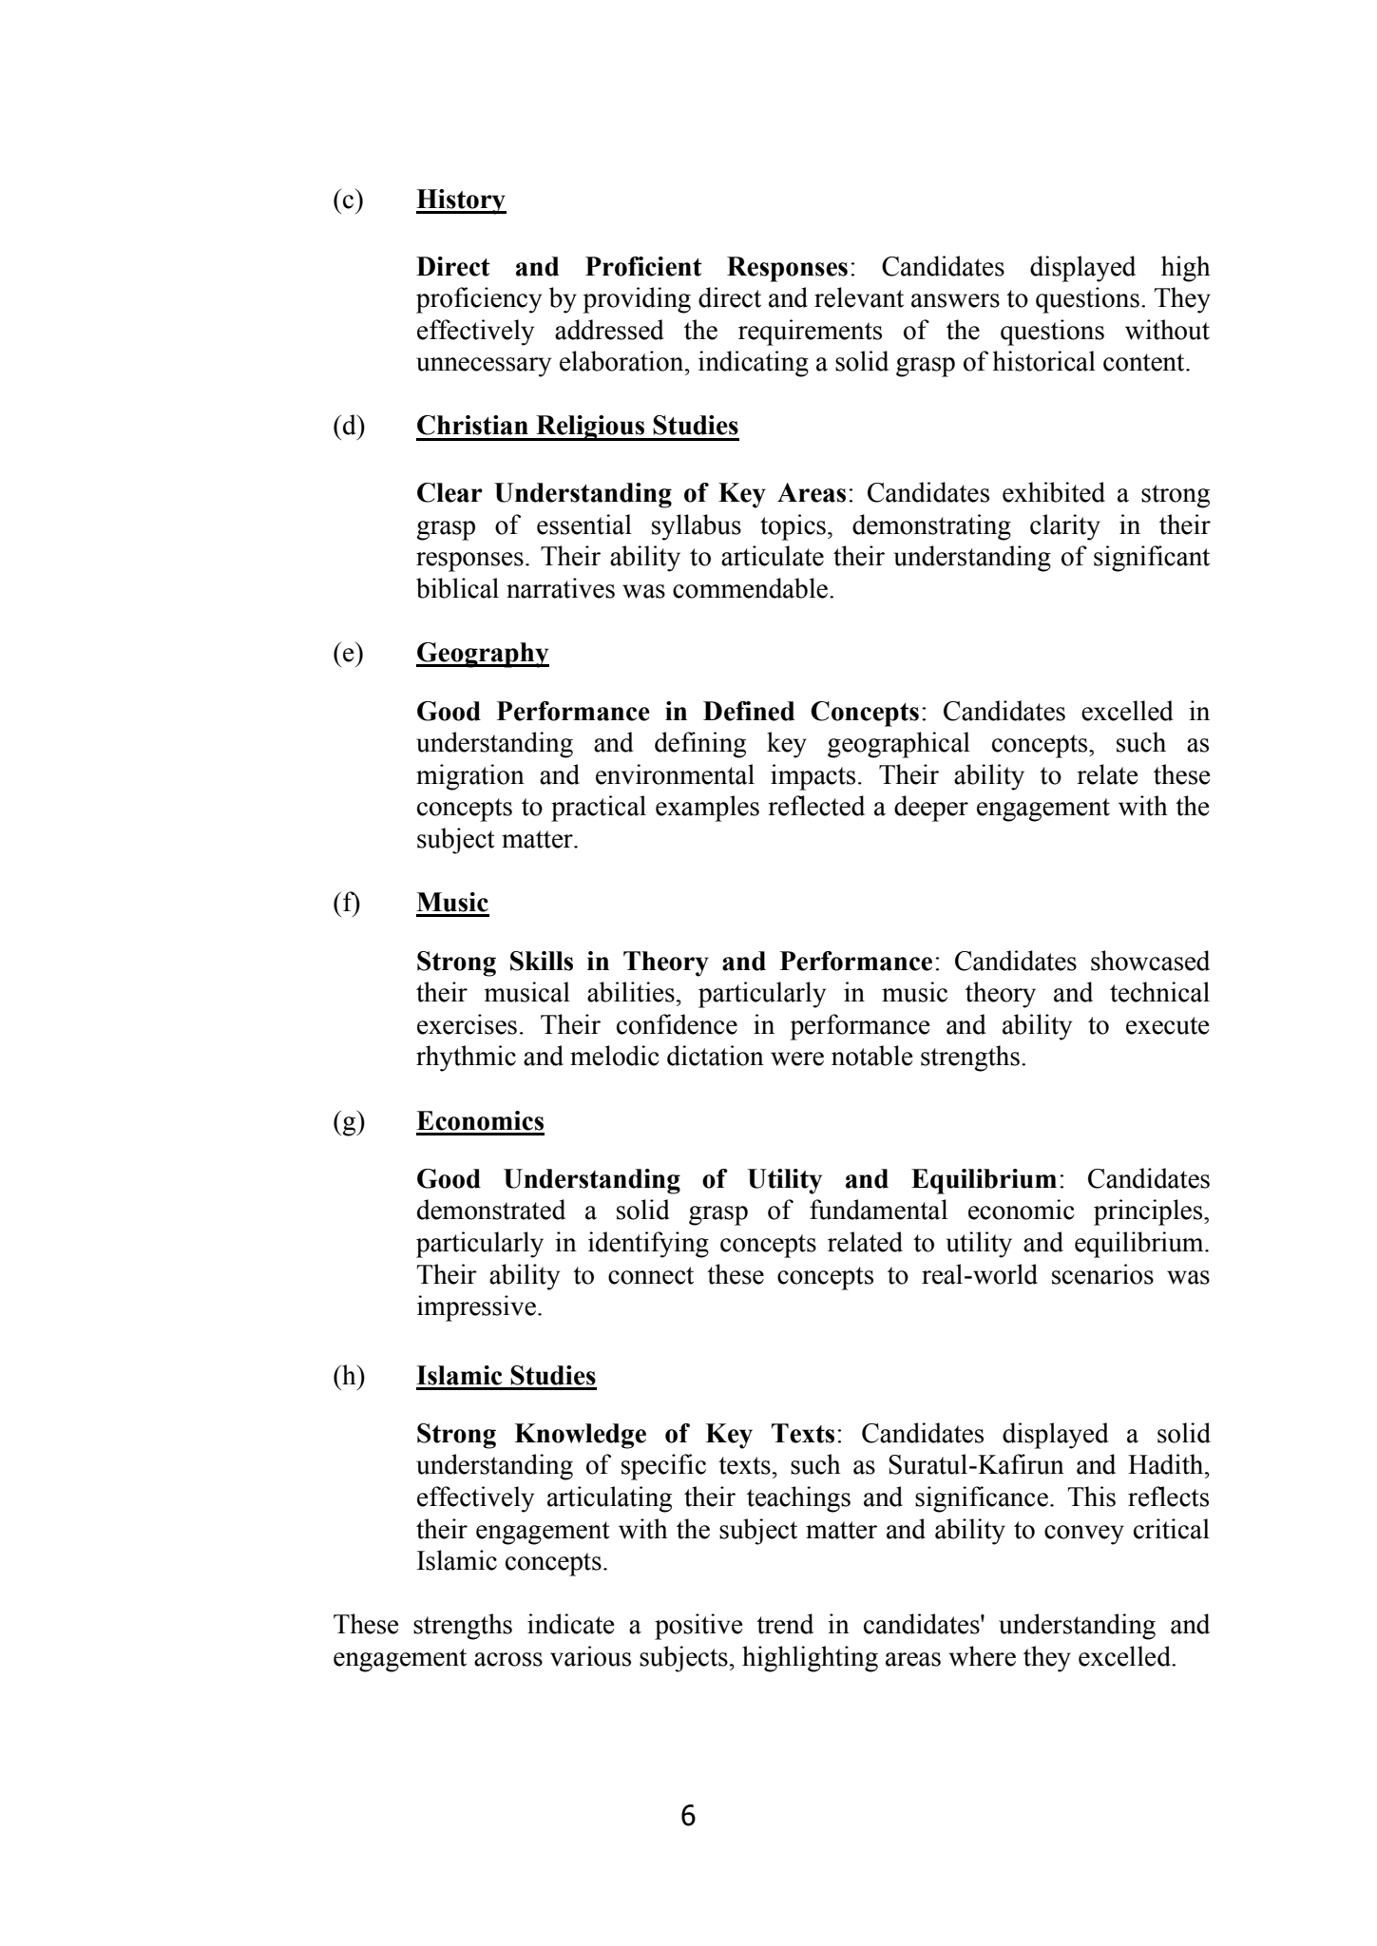
6(c)HistoryDirect and Proficient Responses: Candidates displayed highproficiency by providing direct and relevant answers to questions. Theyeffectively addressed the requirements of the questions withoutunnecessary elaboration, indicating a solid grasp of historical content.(d)Christian Religious StudiesClear Understanding of Key Areas: Candidates exhibited a stronggrasp of essential syllabus topics, demonstrating clarity in theirresponses. Their ability to articulate their understanding of significantbiblical narratives was commendable.(e)GeographyGood Performance in Defined Concepts: Candidates excelled inunderstanding and defining key geographical concepts, such asmigrationand environmental impacts. Their ability to relate theseconcepts to practical examples reflected a deeper engagement with thesubject matter.(f)MusicStrong Skills in Theory and Performance: Candidates showcasedtheir musical abilities, particularly in music theory and technicalexercises. Their confidence in performance and ability to executerhythmic and melodic dictation were notable strengths.(g)EconomicsGoodUnderstanding of Utility and Equilibrium: Candidatesdemonstrated a solid grasp of fundamental economic principles,particularly in identifying concepts related to utility and equilibrium.Their ability to connect these concepts to real-world scenarios wasimpressive.(h)Islamic StudiesStrong Knowledge of Key Texts: Candidates displayed asolidunderstanding of specific texts, such as Suratul-Kafirun and Hadith,effectively articulating their teachings and significance. This reflectstheir engagement with the subject matter and ability to convey criticalIslamic concepts.These strengths indicate a positive trend in candidates' understanding andengagement across various subjects, highlighting areas where they excelled.
- 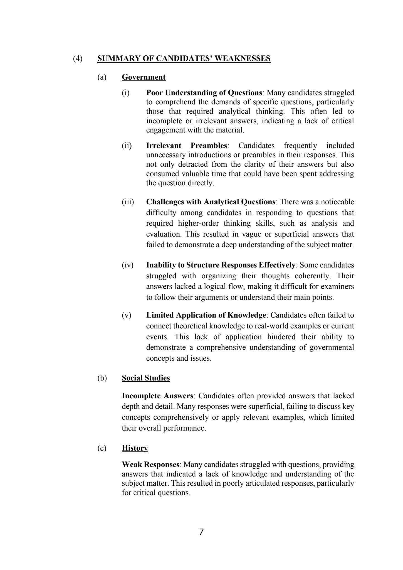
7(4)SUMMARY OF CANDIDATES’ WEAKNESSES(a)Government(i)Poor Understanding of Questions: Many candidatesstruggledto comprehend the demands of specific questions, particularlythose that required analytical thinking. This often led toincomplete or irrelevant answers, indicating a lack of criticalengagement with the material.(ii)Irrelevant Preambles: Candidates frequently includedunnecessary introductions or preambles in their responses. Thisnot only detracted from the clarity of their answers but alsoconsumed valuable time that could have been spent addressingthe question directly.(iii)Challenges with Analytical Questions: There was a noticeabledifficulty among candidates in responding to questions thatrequired higher-order thinking skills, such as analysis andevaluation. This resulted in vague or superficial answers thatfailed to demonstrate adeep understanding of the subject matter.(iv)Inability to Structure Responses Effectively: Some candidatesstruggled with organizing their thoughts coherently. Theiranswers lacked a logical flow, making it difficult for examinersto follow their arguments orunderstand their main points.(v)Limited Application of Knowledge: Candidates often failed toconnect theoretical knowledge to real-world examples or currentevents. This lack of application hindered their ability todemonstrate a comprehensive understanding of governmentalconcepts and issues.(b)Social StudiesIncomplete Answers: Candidates often provided answers that lackeddepth and detail. Many responses were superficial, failing to discuss keyconcepts comprehensively or apply relevantexamples, which limitedtheir overall performance.(c)HistoryWeak Responses: Many candidates struggled with questions, providinganswers that indicated a lack of knowledge and understanding of thesubject matter. This resulted in poorlyarticulated responses, particularlyfor critical questions.
- 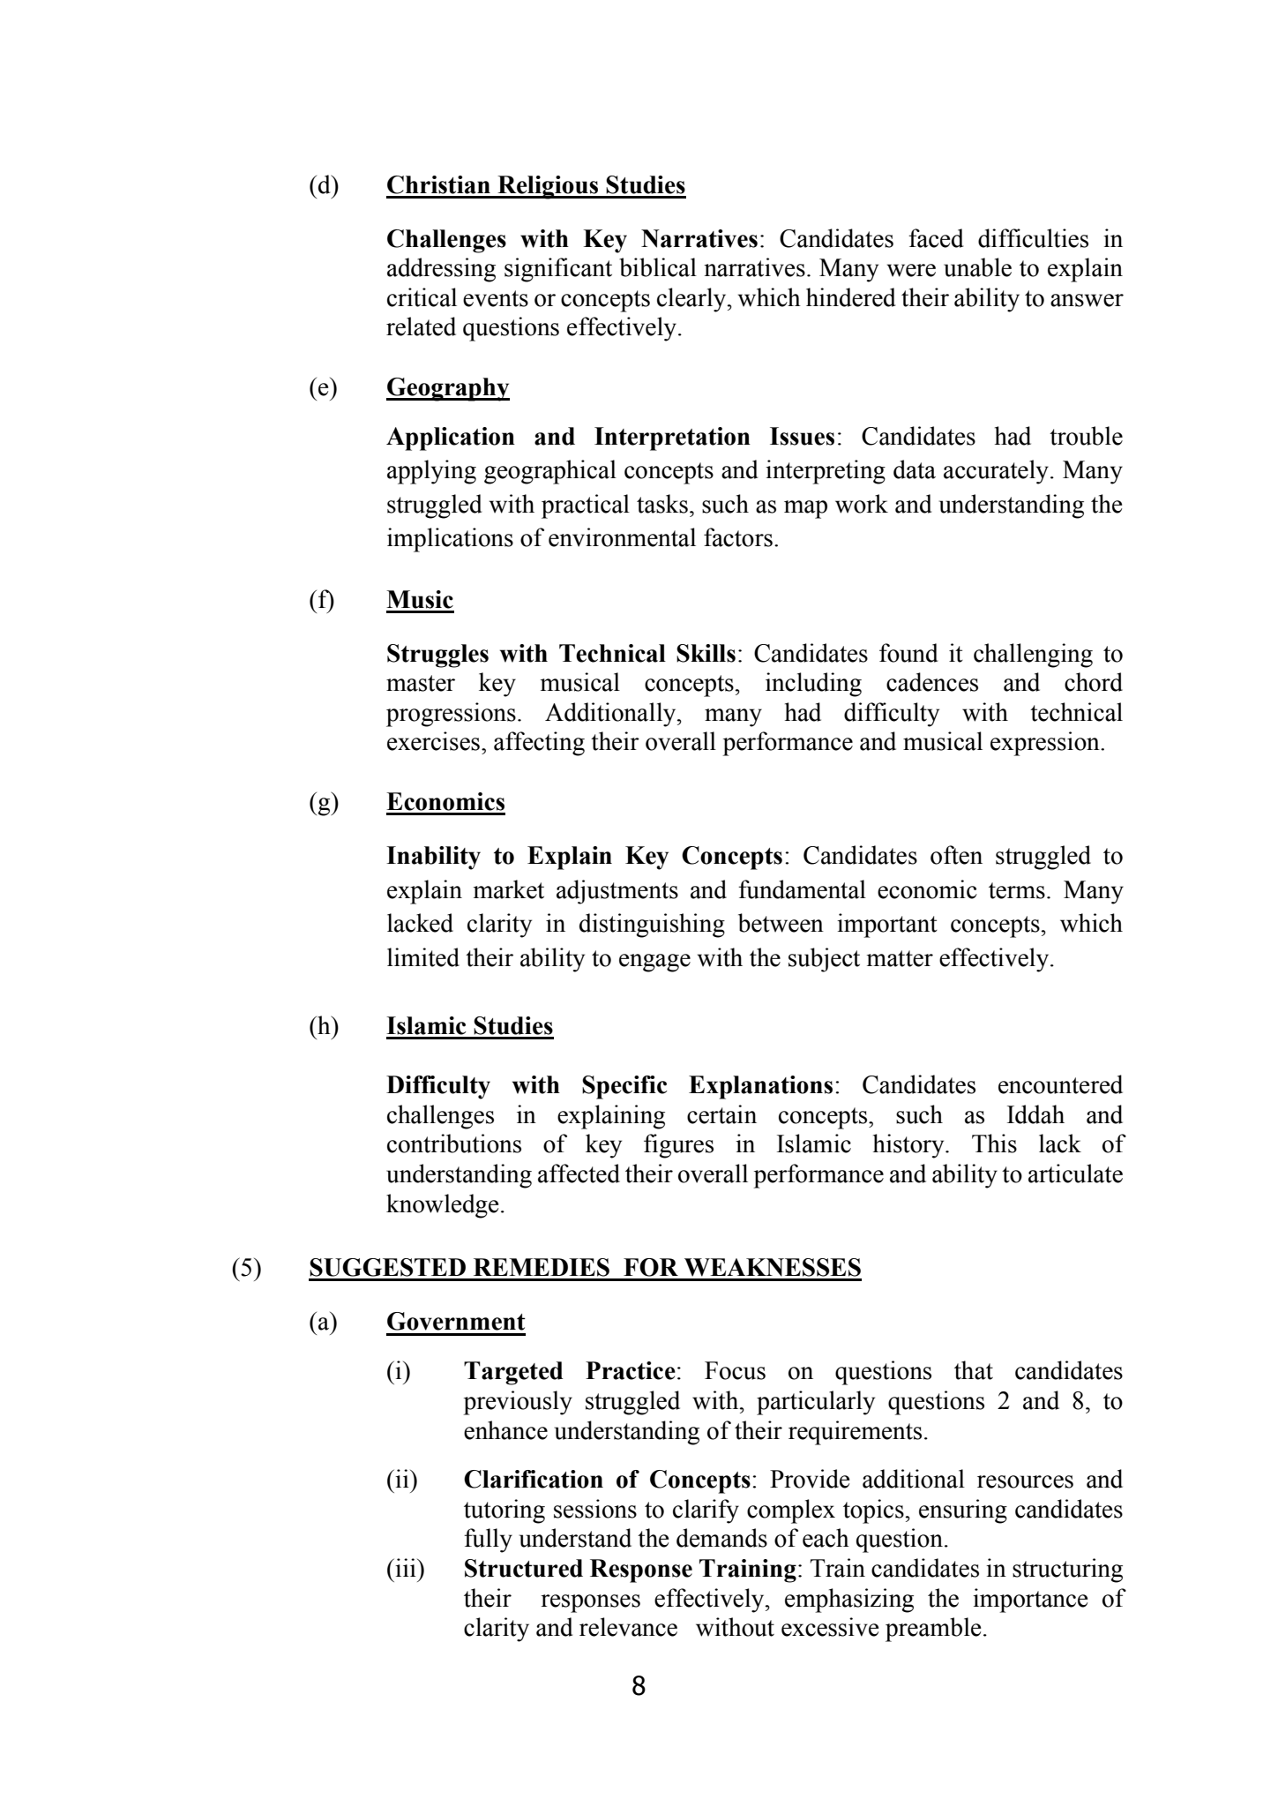
8(d)Christian Religious StudiesChallenges with Key Narratives: Candidates faced difficulties inaddressing significant biblical narratives. Many were unable to explaincritical events or conceptsclearly, which hindered their ability to answerrelated questions effectively.(e)GeographyApplication and Interpretation Issues: Candidates had troubleapplying geographical concepts and interpreting data accurately. Manystruggled withpractical tasks, such as map work and understanding theimplications of environmental factors.(f)MusicStruggles with Technical Skills: Candidates found it challenging tomaster key musical concepts, including cadences and chordprogressions. Additionally, many had difficulty with technicalexercises, affecting their overall performance and musical expression.(g)EconomicsInability to Explain Key Concepts: Candidates often struggled toexplain market adjustments and fundamental economic terms.Manylacked clarity in distinguishing between important concepts, whichlimited their ability to engage with the subject matter effectively.(h)Islamic StudiesDifficulty with Specific Explanations: Candidates encounteredchallenges in explaining certain concepts, such as Iddah andcontributions of key figures in Islamic history. This lack ofunderstanding affected their overall performance and ability to articulateknowledge.(5)SUGGESTED REMEDIES FOR WEAKNESSES(a)Government(i)TargetedPractice: Focus on questions that candidatespreviously struggledwith, particularlyquestions 2 and 8, toenhance understanding of their requirements.(ii)Clarification of Concepts:Provide additional resources andtutoring sessions to clarifycomplex topics, ensuring candidatesfully understand the demands of each question.(iii)Structured Response Training: Train candidates in structuringtheirresponses effectively, emphasizing the importance ofclarity and relevancewithout excessive preamble.
- 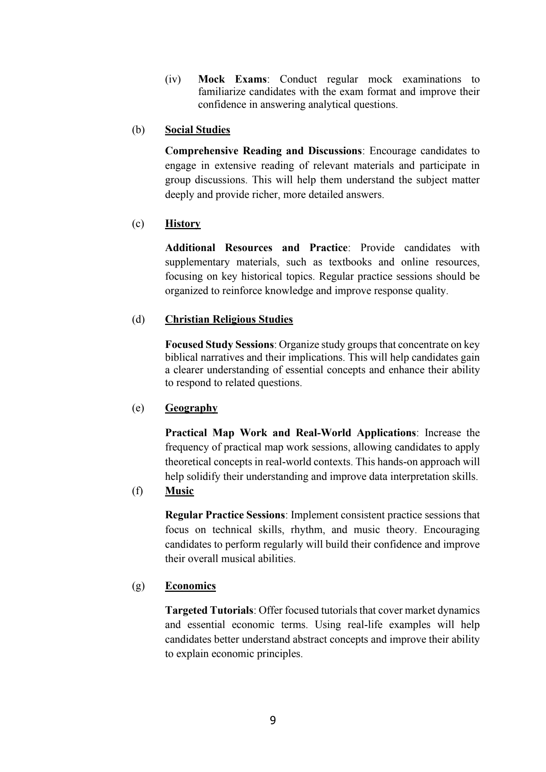
9(iv)Mock Exams: Conduct regular mock examinations tofamiliarize candidates with the exam format and improve theirconfidence in answering analytical questions.(b)Social StudiesComprehensive Reading and Discussions: Encourage candidates toengage in extensive reading of relevant materials and participate ingroup discussions. This will help them understand the subject matterdeeply and provide richer,more detailed answers.(c)HistoryAdditional Resources and Practice: Provide candidates withsupplementary materials, such as textbooks and online resources,focusing on key historical topics. Regular practice sessions should beorganized to reinforce knowledge and improve response quality.(d)Christian Religious StudiesFocused Study Sessions: Organize study groups that concentrate on keybiblical narratives and their implications. This will help candidates gaina clearer understanding of essentialconcepts and enhance their abilityto respond to related questions.(e)GeographyPractical Map Work and Real-World Applications: Increase thefrequency of practical map work sessions, allowing candidates to applytheoretical concepts in real-worldcontexts. This hands-on approach willhelp solidify their understanding and improve data interpretation skills.(f)MusicRegular Practice Sessions: Implement consistent practice sessions thatfocus on technical skills, rhythm, and music theory. Encouragingcandidates to perform regularly will build their confidence and improvetheir overall musical abilities.(g)EconomicsTargeted Tutorials: Offer focused tutorials that cover market dynamicsand essential economic terms. Using real-life examples will helpcandidates better understand abstract concepts and improve their abilityto explain economic principles.

